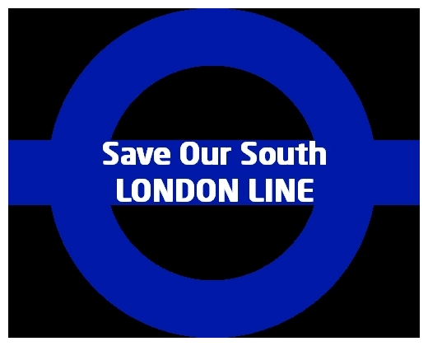

PRESS RELEASE

200 South London Line Campaigners Pack Mayor’s Question Time

Biggest contingent ever on a single issue at any Mayor’s Question Time

Mayor to lead delegation to see Transport Minister

Two hundred people campaigning to save the threatened South London Line packed the London
Mayor’s Question Time in the Brixton Academy last night (1). Organisers of the event have
confirmed that it was the biggest contingent on a single issue ever to attend of the any of the 19
Question Times which have been held (2).

The Mayor has agreed to lead delegation from the South London Line campaign to see the
Transport Minister Sadiq Khan on Wednesday (3).

At last night?s meeting there was strong support from the Greater London Assembly members
present for the campaign to save the South London Line. Liberal Democrat Caroline Pidgeon,
Labour?s John Biggs, Jenny Jones of the Green Party as well as the Chair of the London Assembly
Darren Johnson all stressed the importance of the service.

John Stewart, Co-ordinator of Lambeth Public Transport Group, said, “The support for our campaign was tremendous. The pressure on Transport for London and the Transport Minister to deliver is now overwhelming.”

The South London Line runs from Victoria to London Bridge via Battersea Park, Wandsworth Road, Clapham High St, Denmark Hill, Peckham Rye, Queens Road Peckham and South Bermondsey. It is threatened with closure when the East London Line is extended from Shadwell across the river to Clapham Junction.

ENDS

Notes for Editors:

(1). The Mayor’s ‘People’s Question Time’ was held in the Brixton Academy on 9th November 2009
(2). The total of 19 Question Times include those held by the previous Mayor, Ken Livingstone.

(3). The meeting will be held at the Department for Transport on 11th November at 2.00pm.

For further information: John Stewart on 0207 737 6641; 07957385650

Press Release dated 10th November 2009

