Gary Rice
Head of Development Management
Southwark Council

cc. Jeremy Talbot, case officer;
cc. planning.applications@southwark.gov.uk

Councillor Gordon Nardell
Labour Member for
The Lane Ward
Members’ Room
Southwark Town Hall

Peckham Road
London SE5 8UB

Tel: 07903 964262

E-Mail: gordon.nardell@southwark.gov.uk

Date: 20 April 2010

Dear Gary,

10-AP-0818 – The Hope Public House, 66 Rye Lane, London SE15 5BY -- Application by Paddy Power Limited for illuminated fascia sign and projected sign

I refer to my objection letter on the related application 10-AP-0817. The proposed signage exacerbates the harmful visual impact of the proposal. It is out of character with the existing building and is overdominant and inappropriate in this location.

I urge officers to recommend refusal of this application as well as 10-AP-0817.

Yours sincerely
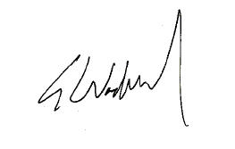
Gordon Nardell
Labour Councillor for The Lane ward

