TfL’s Tube map 2012

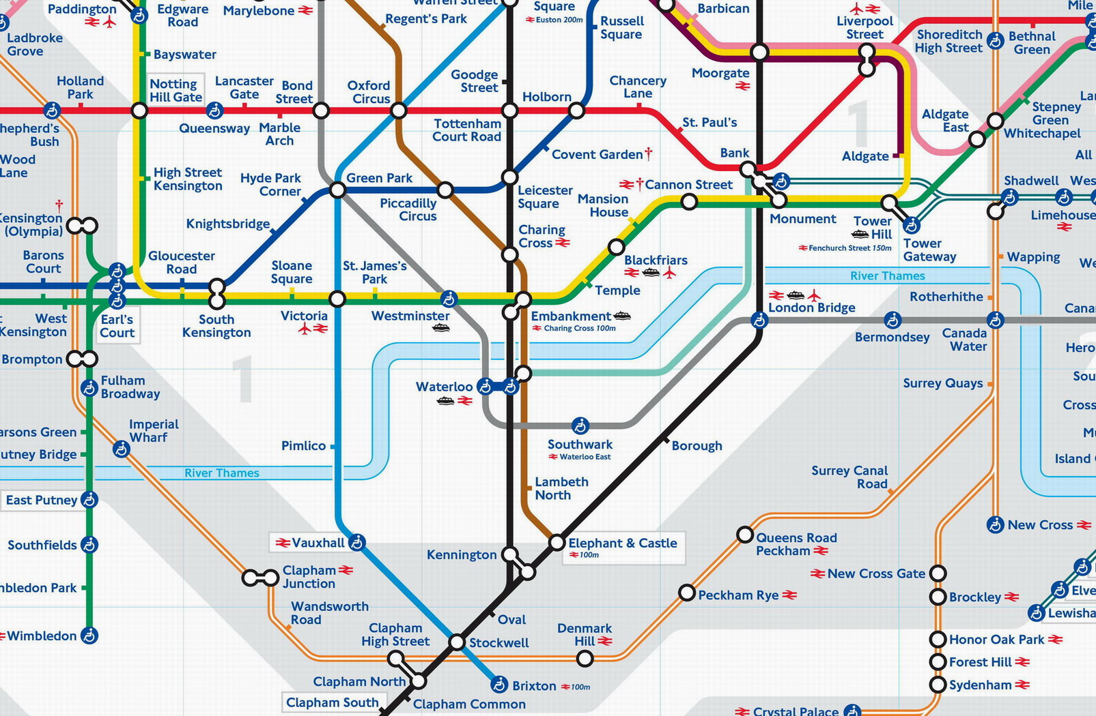
As produced by TfL, showing East London Line Extension (ELLX) both phases 1 & 2 complete,
but apparently no direct rail services to central London from Peckham & Camberwell

Produced by SRUG for the SE5 Forum & Southwark Rail Users’ Group (SRUG) public meeting 30 September 2009

